Paul Velazquez

CS 330

October 15, 2023

Module 7 Project Reflection
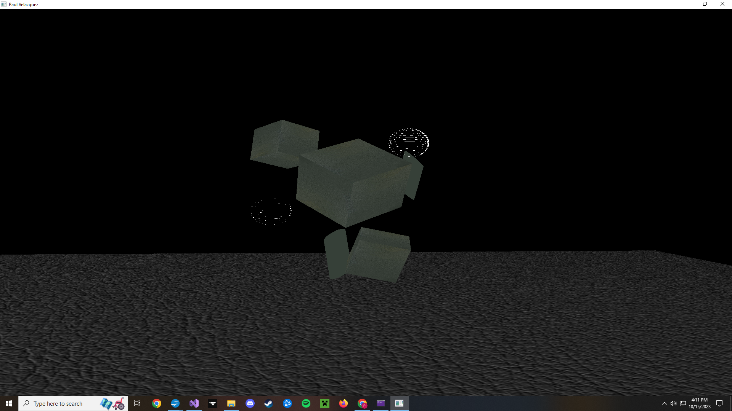
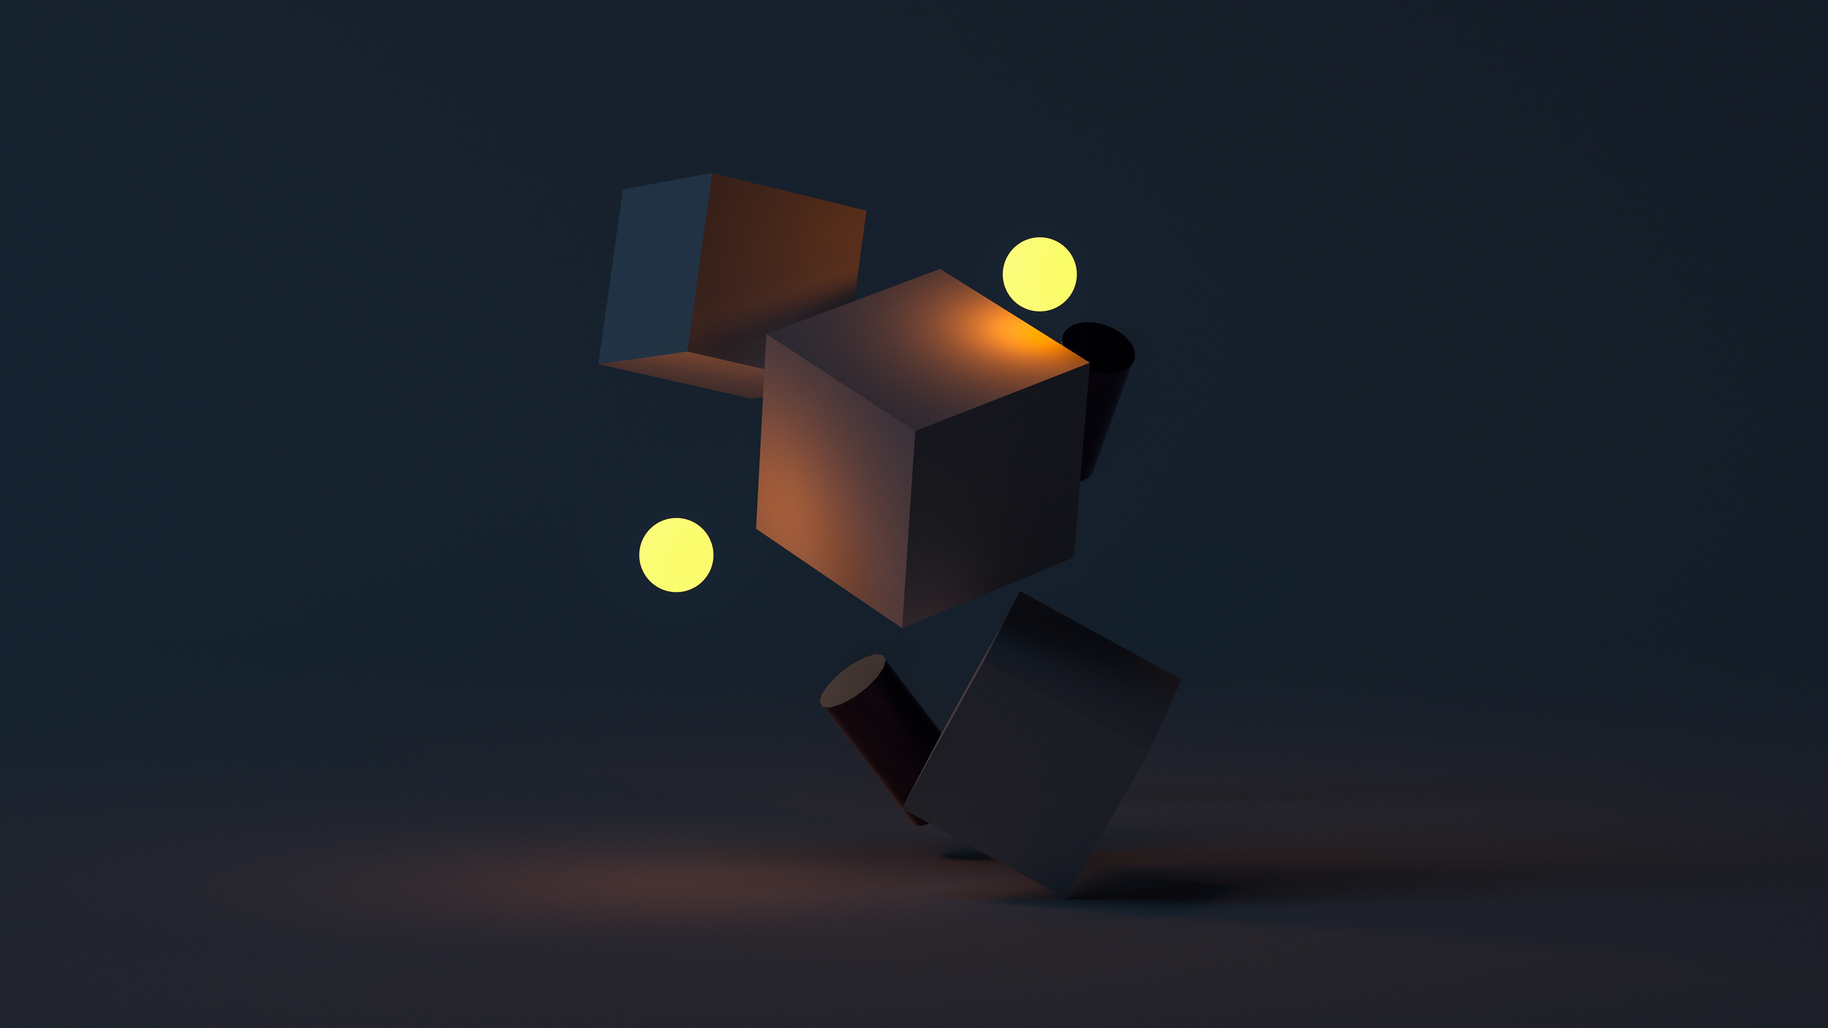

My project involved mapping out a three dimensional scene from a two dimensional representation. The scene included the use of three cubes, two spheres, two cylinders, and a flat plane. The above images show that I was able to accurately render the shapes and apply scaling, translation, and rotation to reconstruct the image in 3D space. I scaled up the plane by a factor of ten to represent the floor, and applied scaling as well as translation and rotation to each of the cubes and cylinders individually to orient them correctly.
My use of textures on the cubes and floor plane did not exactly mimic those of the image, but I felt these choices were appropriate for two reasons. One, they are more highly visible textures than those of the base image to better show correct application, and two, usable textures of the correct size and format were limited in number, and so it was not entirely realistic to find a perfect visual match. Further, I felt these textures were aesthetically pleasing for the image.
One area that proved too challenging for me was the lighting. After including the spheres in the project, I had difficulty in including the necessary shader header program to that was required to create a source of light. After resolving that and successfully including the header, I continued to have other issues in using it, until I eventually attempted to write my own shaders, but without success. I made the decision to sacrifice the lighting of the project to focus on the elements that I could better understand.
At the time that I was making the first cube and floor, the project was still relatively simple, and so the cubes and floor share the same mesh function. When adding other shapes, however, it became more appropriate to keep the code modular, hence the separate mesh function for the spheres and cylinders.
Navigation of the scene is possible with mouse and keyboard. The WASD keys move the camera forward, left, right, and backward respectively, while the mouse changes perspective from a single position. Moving the camera through the scene reveals that some of the shapes are oriented behind others as they appear in the image.

